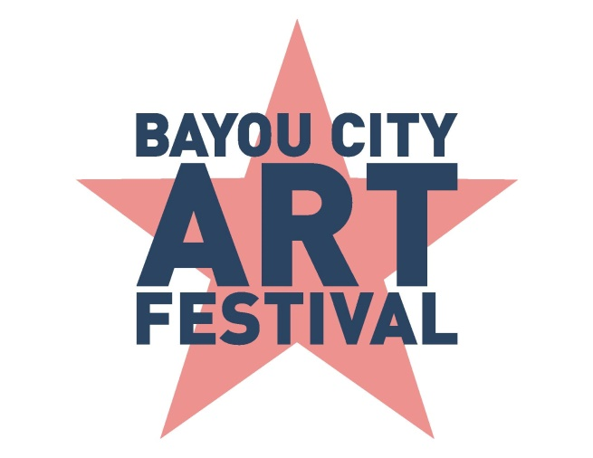
Media Contact
Kim Padgett
The Padgett Group
713-588-4130
kim@thepadgettgroup.com

Bayou City Art Festival Downtown Announces
2019 Houston Nonprofit Beneficiaries

A portion of the proceeds from the two-day outdoor fine art festival will benefit eight local charities

HOUSTON (August 7, 2019) – Bayou City Art Festival Downtown, produced by the Art Colony Association, Inc. (ACA), has selected eight local nonprofits that will benefit from a portion of the proceeds of the event. The weekend festival will be held on Saturday and Sunday, October 12-13, 2019, 10 a.m.-6 p.m. in Downtown Houston.
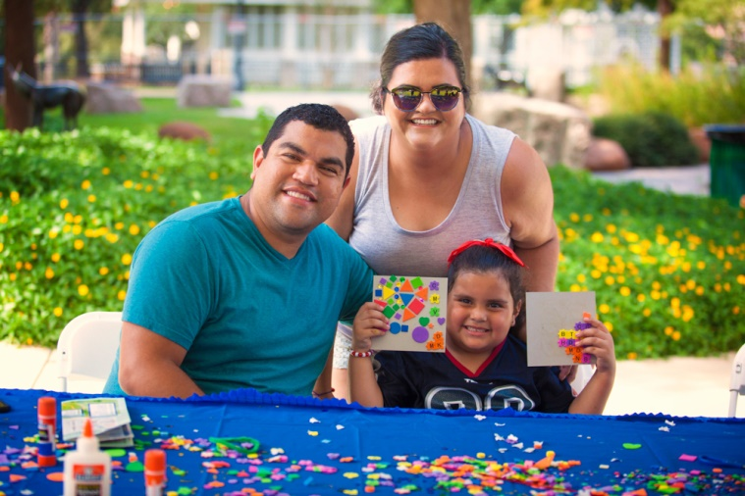
“The Art Colony Association has a rich history of giving back to the community while producing an interactive art event with food and entertainment for all to enjoy,” said Roger Bare, Executive Director of ACA. “With the help of our partners, sponsors, artists and volunteers, we invite patrons to an art festival unlike any other, and to join us in raising funds for Houston-area nonprofits.”

During the past 48 years, attracting crowds of 35,000 annually, the Bayou City Art Festival has raised more than $3.6 million in support of local nonprofit organizations. Each nonprofit provides volunteers and has the option to host an arts and craft station in the Children’s Creative Zone. The eight nonprofit partners benefiting from the 2019 Bayou City Art Festival Downtown include:

- A Cause to Give Us Paws
- Fresh Arts
- Houston SPCA
- Museum of Fine Arts, Houston
- Ronald McDonald House Charities of Greater Houston/Galveston
- The Arc of Greater Houston
- University of Houston - Clear Lake Art Gallery
- Volunteer Houston
Houston’s largest art festival will transform the streets of Downtown into artistic avenues bursting with colors and culture. Bayou City Art Festival will showcase the work of 300 artists from around the world, representing 19 different disciplines. As one of the top art festivals in the country, the weekend event will provide guests with the opportunity to personally meet artists, view original works, and purchase world-class art, prints, jewelry, sculptures and more.

Bayou City Art Festival Downtown will feature live music throughout the festival along with entertainment, beverage stations, food trucks and much more for patrons to enjoy. In addition to art activities, the Children’s Creative Zone will also feature giant bubbles and caricature artist Bonnie Blue.

This year’s featured artist Clifton Henri is an award-winning photographer and visual artist from Chicago. His work is rooted in identity, under representation and self-declaration. Henri visually illustrates and narrates the African diaspora using personal experiences and feelings as fuel for his portraits.

Online tickets are now available at www.artcolonyassociation.org. Tickets online are $12 for adults and $5 for children 6 – 12; children five and under are free. Two-day passes are available online for $20 and family passes (two adults, two children tickets) for $30. Adult tickets at the gate are $15 cash; $16 credit card.
For updates on social media, follow the official event hashtags #HouArtFest and #BCAF, like the Facebook page, or follow on Twitter and Instagram. Also, subscribe to our newsletter here.

About Bayou City Art Festival:
Now in its 48th year since the founding of the Westheimer Art Festival, now known as Bayou City Art Festival, the Art Colony Association, Inc. has raised more than $3.6 million for local nonprofit programs from proceeds of its festivals. Bayou City Art Festival Memorial Park in the spring and Bayou City Art Festival Downtown in the fall has provided a venue for over 20,000 artists to showcase their work to thousands of art lovers from all over the world. A percentage of the proceeds support local art organizations and nonprofits. The festivals are funded in part by grants from the City of Houston through the Houston Arts Alliance, corporate sponsorships, private contributions, in-kind support and volunteer assistance.

Volunteer and sponsorship opportunities are available. For more information, please visit www.artcolonyassociation.org.
###

