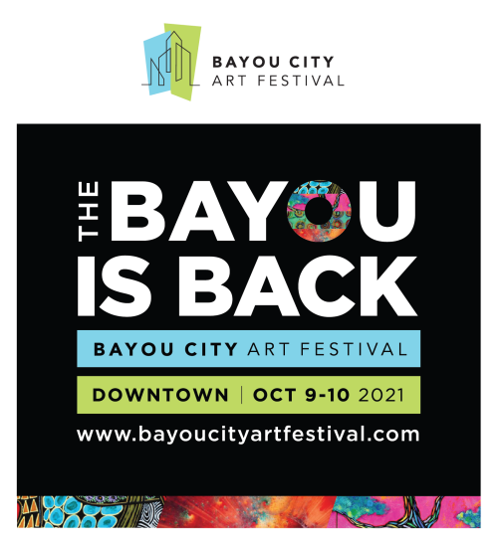

Media Contact
Kim Padgett
The Padgett Group
713-588-4130
kim@thepadgettgroup.com

Bayou City Art Festival Returns to
Downtown Houston in the Fall

Bayou City Art Festival Downtown: Saturday & Sunday, October 9-10, 2021

HOUSTON (July 20, 2021) – The Art Colony Association, Inc. (ACA), the producer of Bayou City Art Festival, will welcome artists, patrons and supporters back for Houston’s signature art event. The in-person festival, Bayou City Art Festival Downtown, will be held in Downtown Houston, along Allen Parkway and Sam Houston Park, on Saturday and Sunday, October 9-10, 2021, 10 a.m. - 6 p.m.
Bayou City Art Festival will spotlight the festival’s featured artist McKenzie Fisk, a painter from Los Angeles, as it transforms the streets of Downtown into artistic avenues bursting with colors and culture. As one of the top art festivals in the country, the weekend event will provide patrons with the opportunity to personally meet artists, view original works, and purchase artwork from 19 art disciplines including world-class paintings, prints, jewelry, sculptures and more.
The festival will feature live music, food trucks, and beverage stations throughout the festival along with two entertainment stages and art installations. Guests will enjoy Houston’s skyline views while enjoying the festival’s wine garden, craft beer garden and Art Bar. In the Active Imagination Zone, the festival’s nonprofit partners will host hands-on art activities for all ages.
For the ultimate art lover, Bayou City Art Festival and Frost Bank will offer a limited availability VIP ticket experience, which will include a tented oasis with light bites, and complimentary beer, wine and other beverages. The relaxing setting under a canopy of trees will feature roaming musicians, artistic décor, a phone charging station and more. VIPs will receive all-day access to the VIP area, along with VIP parking.
A portion of the proceeds from Bayou City Art Festival Downtown will benefit the festival’s nonprofit partners including Artists For Artists, Fresh Arts, Houston SPCA, Warriors In Art, Orange Show For Visionary Art, and The Museum of Fine Arts, Houston.
Online early bird tickets will soon be available at www.bayoucityartfestival.com for $15 for adults; $5 for children 6-12; and children five and under are free. Adult tickets purchased after September 24, 2021 are $18. Online pre-purchased tickets are required to enter the festival. Tickets will not be sold at the gate and can only be purchased online.
Bayou City Art Festival has celebrated and supported artists, local nonprofits, and promoted the powerful impact that art has on the Houston community for almost 50 years. The “Save Our Art” campaign launched in 2020 in partnership with the City of Houston continues to help Bayou City Art Festival keep the arts alive. For more information and to donate, visit www.artcolonyassociation.org/donate-today.
For the most recent updates, follow the official event hashtags #HouArtFest and #BCAF, like the Facebook page, or follow on Twitter and Instagram. Also, subscribe to our newsletter here.
About Bayou City Art Festival:
Since the founding of the Westheimer Art Festival, now known as Bayou City Art Festival, the Art Colony Association, Inc. has raised more than $3.6 million for local nonprofit programs from the proceeds of its festivals. Bayou City Art Festival Memorial Park in the spring and Bayou City Art Festival Downtown in the fall has provided a venue for more than 20,000 artists to showcase their work to thousands of art lovers from all over the world. The festivals are funded in part by grants from the City of Houston through the Houston Arts Alliance, corporate sponsorships, private contributions, in-kind support and volunteer assistance.

For more information, please visit www.artcolonyassociation.org.
###

