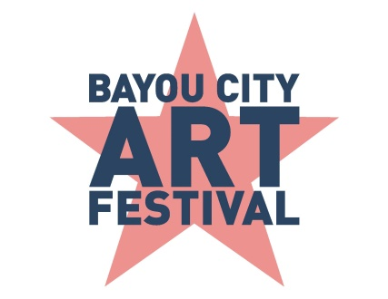

Media Contact
Kim Padgett
The Padgett Group
713-588-4130
kim@thepadgettgroup.com

Call for Artists: Bayou City Art Festival Memorial Park 2020

HOUSTON (November 5, 2019) – Bayou City Art Festival, produced by the Art Colony Association, Inc. (ACA) and benefitting Houston nonprofits, is inviting artists to submit an application for the opportunity to showcase and sell their art at the nation’s premier spring outdoor art festival in the U.S. on Friday-Sunday, March 27-29, 2020. The artist application deadline for the 2020 Bayou City Art Festival Memorial Park is Monday, December 2, 2019 at midnight CST.

“Artists are the soul of our festival and help bring Bayou City Art Festival to life with their unique vibrant artwork,” said Kelly Batterson, Executive Director of ACA. “We invite new and returning artists to apply and challenge them to create something special that connects with our art loving patrons.”

ACA produces Bayou City Art Festival Memorial Park in the spring and Bayou City Art Festival Downtown in the fall. Entering its 49th year in 2020, ACA has provided a venue for more than 20,000 artists to showcase their work to thousands of art lovers from all over the world. Patrons have the opportunity to personally meet the artists, view original works, and purchase world-class art. The festival benefits local nonprofits and features live music, food, beverages, entertainment, a Children’s Creative Zone and much more.

Twice a year, more than 1,000 qualified applicants from 19 different disciplines submit their applications to be reviewed by ACA jurors. The festival receives applicants from around the world including Canada, Mexico, South America and Israel. For artists who have participated in two or fewer juried art festivals, Bayou City Art Festival invites them to apply for its Emerge: Artists on the Rise program. Selected “Artists on the Rise” will receive a booth in a dedicated area alongside other exhibiting artists and can submit a fifth image of their work in lieu of a booth image.

For each festival, a new juror panel is invited and consists of artists, collectors, educators, curators and industry professionals. To build a jury that is experienced in all forms of art, professionals from the performing and literary arts industry are also invited to participate. The panel of five to seven jurors are selected based on their specific interests, professional knowledge, and expertise in the arts.

Only 300 artists will be selected to exhibit at the 2020 Bayou City Art Festival Memorial Park. Cash prizes are awarded for “Best in Show”, second and third place, as selected by on-site judges at the festival. Ribbons are awarded for “Best Booth” and all winners receive jury exempt status for two years as well as priority booth placement.

Artists are required to submit five images and an application fee of $45 by the deadline. All artists selected to participate in the 2020 Bayou City Art Festival Memorial Park will be notified by Friday, December 13, 2019. For more information or to submit an artist application for Bayou City Art Festival Memorial Park, please click here.

For updates on social media, follow the official event hashtags #HouArtFest and #BCAF, like the Facebook page, or follow on Twitter and Instagram. Also, subscribe to our newsletter here.

About Bayou City Art Festival:

Entering its 49th year in 2020, the Bayou City Art Festivals have raised more than $3.6 million for local nonprofit programs from proceeds of its festivals. Bayou City Art Festival Memorial Park in the spring and Bayou City Art Festival Downtown in the fall has provided a venue for over 20,000 artists to showcase their work to thousands of art lovers from all over the world. A percentage of the proceeds support local art organizations and nonprofits. The festivals are funded in part by grants from the City of Houston through the Houston Arts Alliance, corporate sponsorships, private contributions, in-kind support, and volunteer assistance.

Volunteer and sponsorship opportunities are available. For more information, please visit www.artcolonyassociation.org
###

