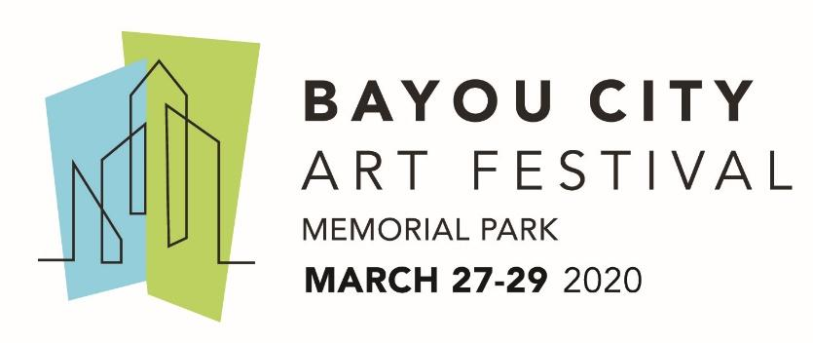
Media Contact
Kim Padgett
The Padgett Group
713-588-4130
kim@thepadgettgroup.com

Art Colony Association Announces Bayou City Art Festival Memorial Park Featured Artist: McKenzie Fisk

Friday-Sunday, March 27-29, 2020

HOUSTON (December 10, 2019) – The Art Colony Association, Inc. (ACA) has announced the Bayou City Art Festival Memorial Park 2020 featured artist is McKenzie Fisk, a painter from Los Angeles. Fisk, along with 300 artists from around the country, representing 19 different disciplines will showcase their art at Bayou City Art Festival Memorial Park. The festival benefits Houston nonprofits, and will be held on Friday-Sunday, March 27-29, 2020. 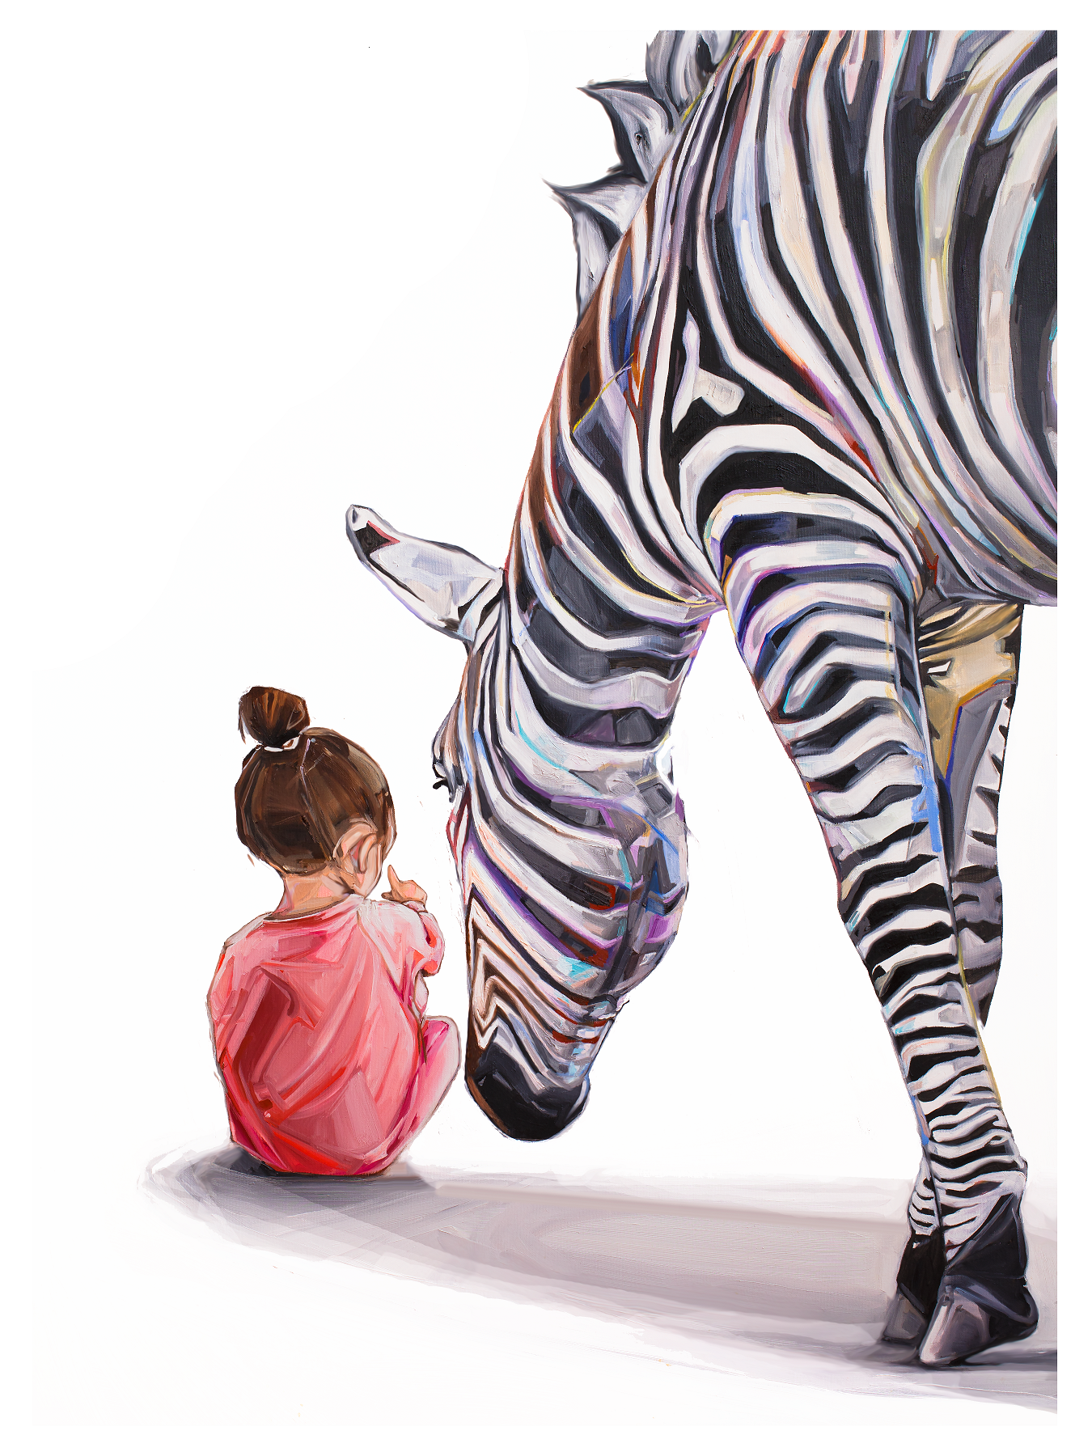

Fisk knew she wanted to grow up to be an artist since she was a child. As an adult, she neglected her passion for creating art while earning a Bachelor’s in Microbiology and Fine Art, followed by a Master’s in Physiology from Columbia University in New York City. A year after launching her own business, Fisk began painting in her free time. She quickly realized that art could be as intellectual as science and rediscovered her happiness for painting. Realizing the stories behind her art and its aesthetics were gaining notice, she decided to follow her heart and pursue her passion full-time. 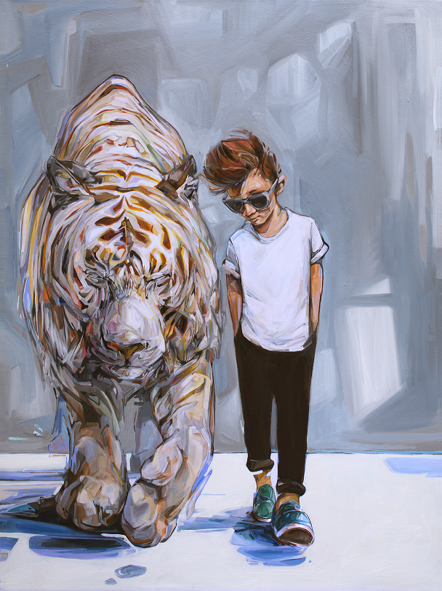

In 2014, she sold her company and moved to California. Using geometric shapes along with bright colors, Fisk paints both children and animals in relatable moments as they experience life with new eyes. She captures innocence while exploring and enjoying life’s simple pleasures. Fisk adds slightly broken pieces in her work to demonstrate experiences and how people disassemble and reassemble themselves and their lives. 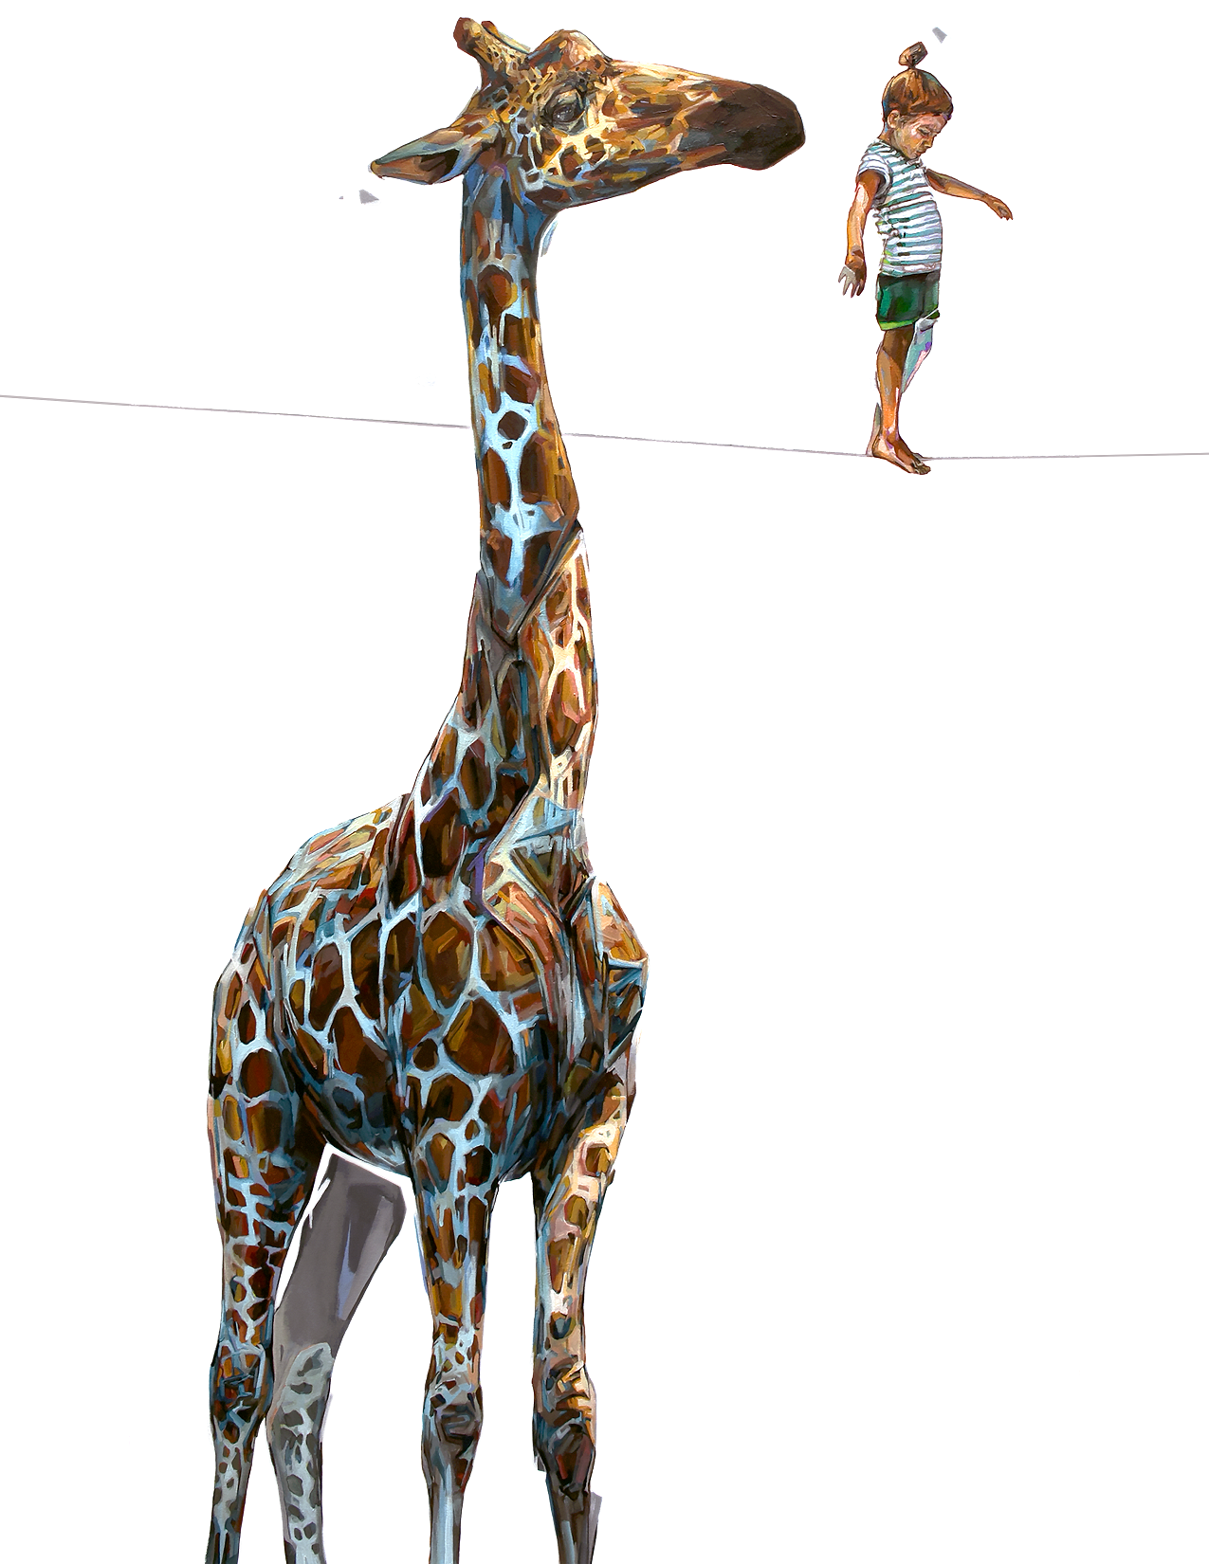

As one of the nation’s premier outdoor fine art events, Bayou City Art Festival Memorial Park provides guests with the opportunity to meet artists, view original works, and purchase one-of-a-kind art, prints, jewelry, sculptures, functional art and more. The three-day festival features live music, local food vendors and food trucks, beverages, entertainment, a Children’s Creative Zone and much more. An exhibition of student artwork composed of the top 30 finalists from the Middle School Art Competition will also be featured.

Online tickets are available now at www.artcolonyassociation.org. Tickets purchased online are $12 for adults and $5 for children 6 – 12; children five and under are free. Two-day passes for $20 and family passes (two adults, two children tickets) for $30. Individual tickets can also be purchased at the gate on festival days for $15 cash or $16 with a credit card.

For the most recent updates, follow the official event hashtags #HouArtFest and #BCAF, like the Facebook page, or follow on Twitter and Instagram. Also, subscribe to our newsletter here.

###

