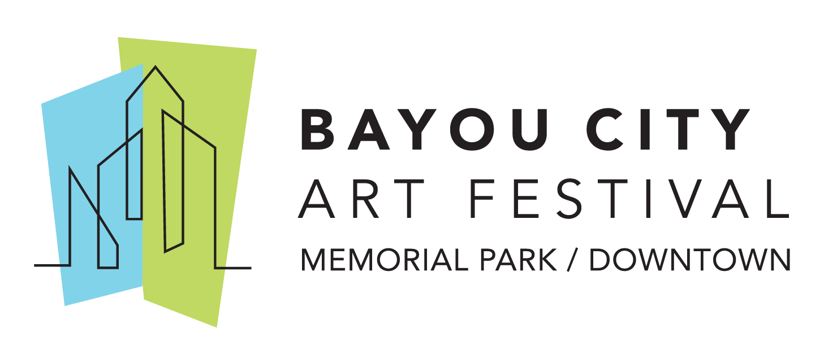 Media Contact
Kim Padgett, The Padgett Group
713-588-4130
kim@thepadgettgroup.com

Art Colony Association, Inc. Announces 8th Annual Middle School Art Competition Winners

HOUSTON (April 6, 2020) The Art Colony Association, Inc. (ACA), the producer of Bayou City Art Festival, has announced the winners from the 8th Annual Middle School Art Competition. The art competition is an education initiative offered by ACA that gives students in grades 5th- 8th from the Greater Houston area the opportunity to participate in a 2-D juried competition, have their art displayed in public, interact with working artists, and win prizes for themselves and their school’s art program.

The top three winners and the winner of the online Jim Barron People’s Choice Award are:

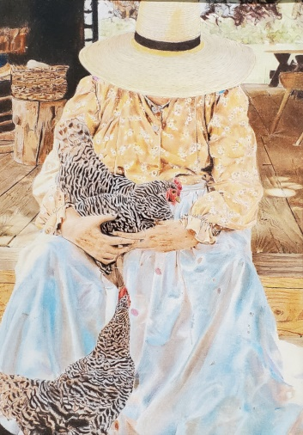
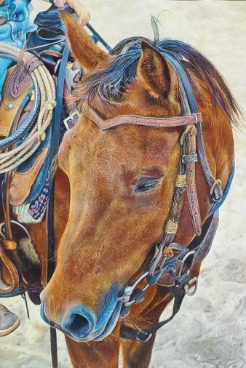
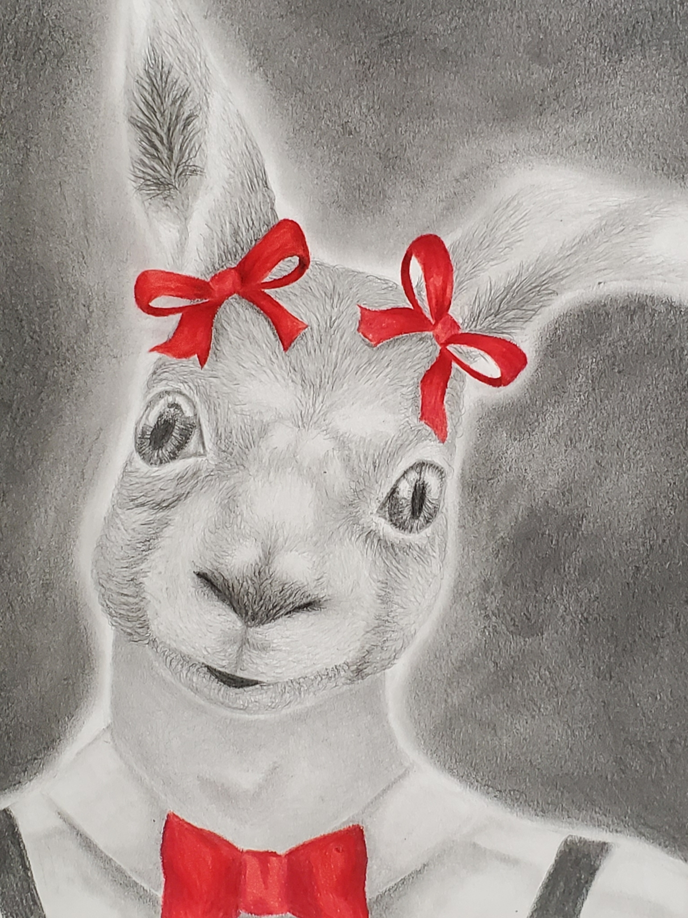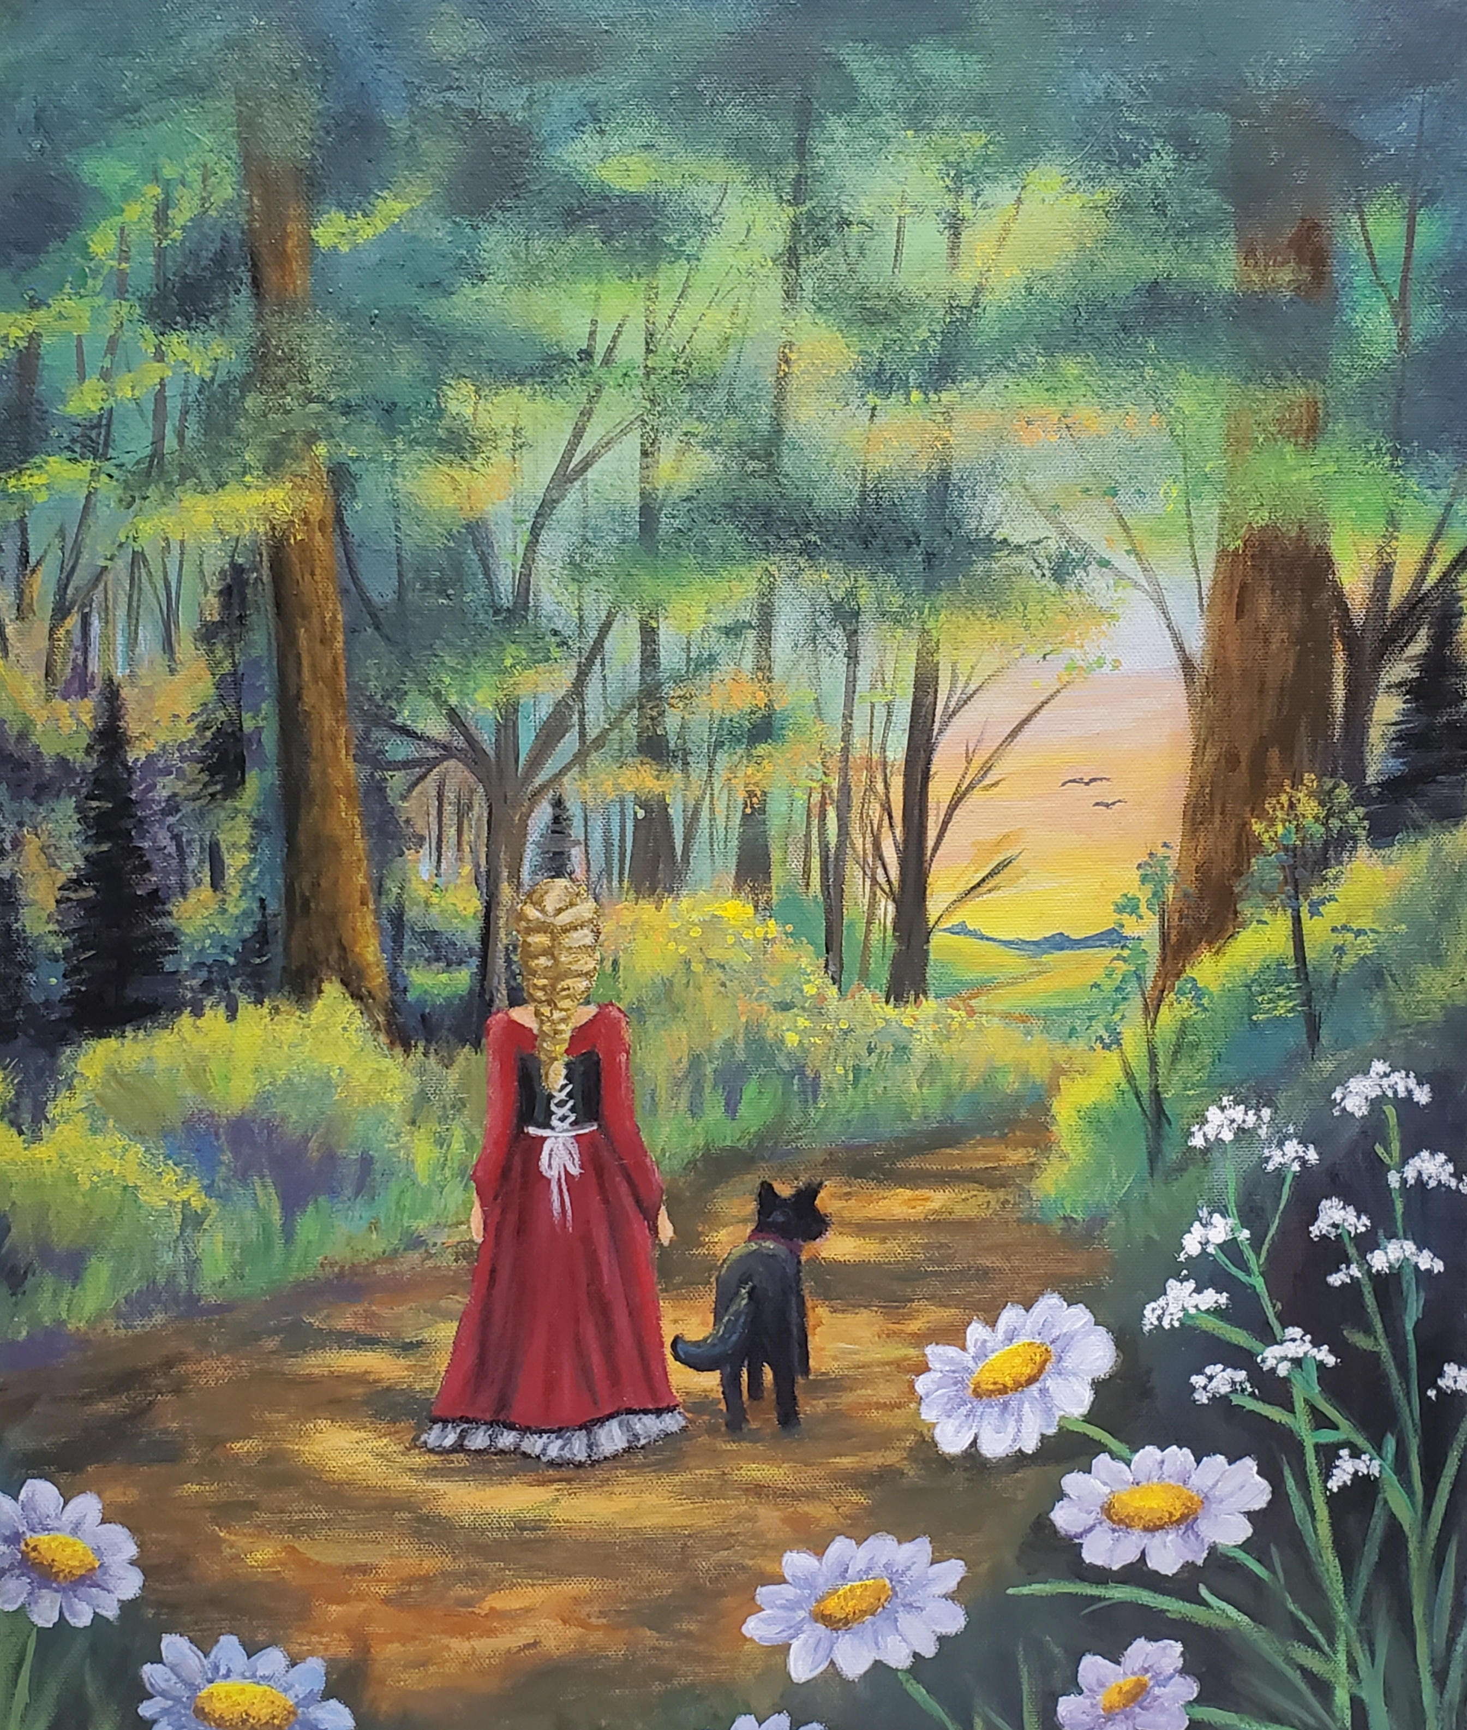

Jim Barron People’s Choice Award
“The Journey"
by Arianna Digman from Schindewolf Intermediate School (Klein ISD)
​

3rd Place
"Quincy Rabbit"
by Casandra Magee from Riverwood Middle School (Humble ISD)
​

2nd Place
"Indigo Rider"
by Alejandra Rincon from WoodCreek Junior High (Katy ISD)
​

1st Place
"Southern Lovin'"
by Jia Luthra from Tays Jr. High School (Katy ISD)
​

ACA is dedicated to h
1st Place
"Southern Lovin'"
by Jia Luthra

ACA is dedicated to helping arts education while partnering with teachers and students in the Greater Houston area. Over 400 students participated in the annual art competition and the artwork from the 2020 Middle School Art Competition finalists are posted online at www.artcolonyassociation.org/education.

On October 10-11, 2020, Bayou City Art Festival will offer the city’s Downtown iconic buildings as a backdrop for guests to meet artists, view original works, and purchase one-of-a-kind art, prints, jewelry, sculptures, functional art and more. Bayou City Art Festival Downtown will feature 300 artists, two music stages, a culinary arts stage with chef demonstrations, strolling live entertainment, food trucks, and a craft beer and wine garden. In the Children’s Creative Zone sponsored by Texas Children’s Hospital Specialty Care, the festival’s nonprofit partners will host art activities for all ages and include an interactive area for all attendees to enjoy.

About Bayou City Art Festival:
In its 49th year since the founding of the Westheimer Art Festival, now known as Bayou City Art Festival, the Art Colony Association, Inc. has raised more than $3.6 million for local nonprofit programs from proceeds of its festivals. Bayou City Art Festival Memorial Park in the spring and Bayou City Art Festival Downtown in the fall has provided a venue for more than 20,000 artists to showcase their work to thousands of art lovers from all over the world. The festivals are funded in part by grants from the City of Houston through the Houston Arts Alliance, corporate sponsorships, private contributions, in-kind support and volunteer assistance.

Volunteer and sponsorship opportunities are available. For more information, please visit www.artcolonyassociation.org.
###

