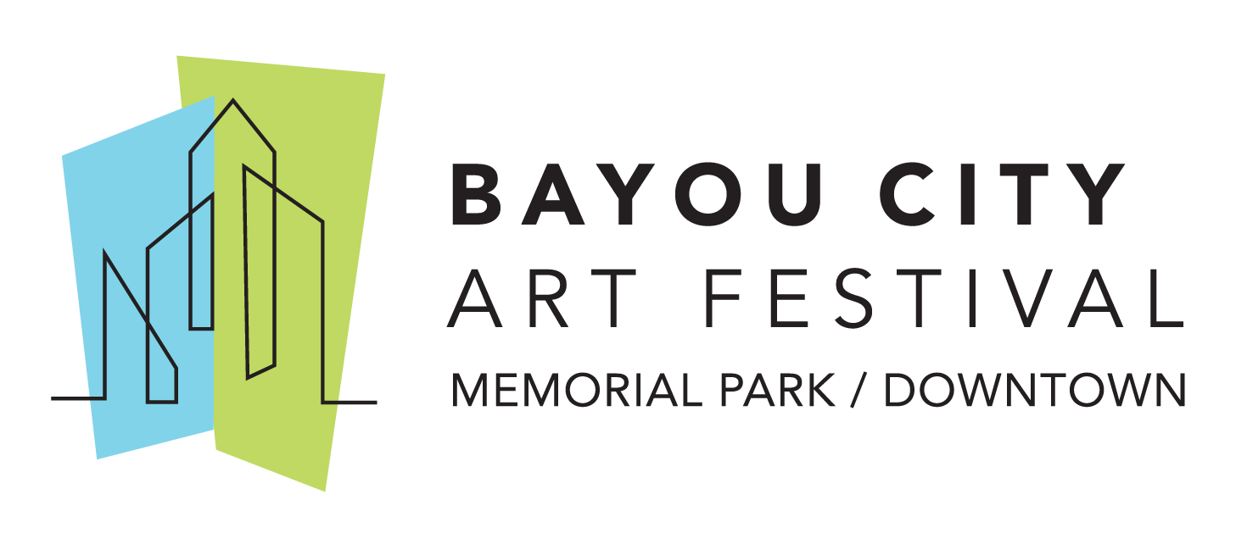

Media Contact
Kim Padgett
The Padgett Group
713-588-4130
kim@thepadgettgroup.com

Anonymous $450,000 Donation Provides All Bayou City Art Festival Memorial Park 2020 Artists with Cash Grant

Save the date for Bayou City Art Festival Downtown: Saturday & Sunday, October 10-11, 2020
HOUSTON (April 22, 2020) – The Art Colony Association, Inc. (ACA), the producer of Bayou City Art Festival, has announced that an anonymous donor has donated $450,000 that will provide all 300 2020 Bayou City Art Festival Memorial Park artists with a cash grant for $1500 each. In addition, all artists confirmed for the Memorial Park festival that was canceled due to the Coronavirus have been invited to exhibit in the Bayou City Art Festival Downtown on Saturday-Sunday, October 10-11, 2020.
A check for each Memorial Park 2020 artist has been distributed by the festival’s nonprofit partner Artists for Artists, a 501(c)3 nonprofit organization that provides Emergency Recovery Grants and free medical programming to Houston-based artists. The generous donation was made as a contribution to Artists for Artists in memory of the donor’s mother, a Bayou City Art Festival patron and art lover.
The anonymous donor wanted to help artists of the Memorial Park festival during this unprecedented time and reviewed the nonprofit partners on the Bayou City Art Festival website. The donor contacted Artists for Artists to assist in providing the donation that is specifically designated to provide financial assistant to those artists who were scheduled to exhibit at Bayou City Art Festival Memorial Park.
“We are so thankful for our partnership with Artists for Artists and the kindness of the anonymous donor. As we work together to press forward and plan for Bayou City Art Festival Downtown in the fall, we hope this generous grant will help our artists during this challenging time,” said Kelly Batterson, Executive Director of ACA.
The local organization, Artists for Artists, was selected for the first time as a nonprofit partner for this year’s Bayou City Art Festival Memorial Park. Artists for Artists, along with Fresh Arts, Houston SPCA, Warriors in Art, Orange Show Center for Visionary Arts and The Museum of Fine Arts, Houston will participate as the nonprofit partners for Bayou City Art Festival Downtown and will benefit from a portion of the proceeds from the fall festival.
McKenzie Fisk, a painter from Los Angeles will be the featured artist for Bayou City Art Festival Downtown. Fisk along with 300 artists, representing 19 different disciplines will showcase their art in Downtown Houston.
Bayou City Art Festival Downtown offers the city’s iconic buildings as a backdrop for guests to meet artists, view original works, and purchase one-of-a-kind art, prints, jewelry, sculptures, functional art and more. Bayou City Art Festival Downtown will feature two music stages, a culinary arts stage with chef demonstrations, strolling live entertainment, food trucks, and a craft beer and wine garden. In the Children’s Creative Zone sponsored by Texas Children’s Hospital Specialty Care, the festival’s nonprofit partners will host art activities for all ages and include an interactive area for all attendees to enjoy.
All tickets purchased in advance for the Memorial Park 2020 Festival will be honored at the Downtown Festival in October 2020.
About Bayou City Art Festival:
In its 49th year since the founding of the Westheimer Art Festival, now known as Bayou City Art Festival, the Art Colony Association, Inc. has raised more than $3.6 million for local nonprofit programs from proceeds of its festivals. Bayou City Art Festival Memorial Park in the spring and Bayou City Art Festival Downtown in the fall has provided a venue for more than 20,000 artists to showcase their work to thousands of art lovers from all over the world. The festivals are funded in part by grants from the City of Houston through the Houston Arts Alliance, corporate sponsorships, private contributions, in-kind support and volunteer assistance.

Volunteer and sponsorship opportunities are available. For more information, please visit www.artcolonyassociation.org.
###

