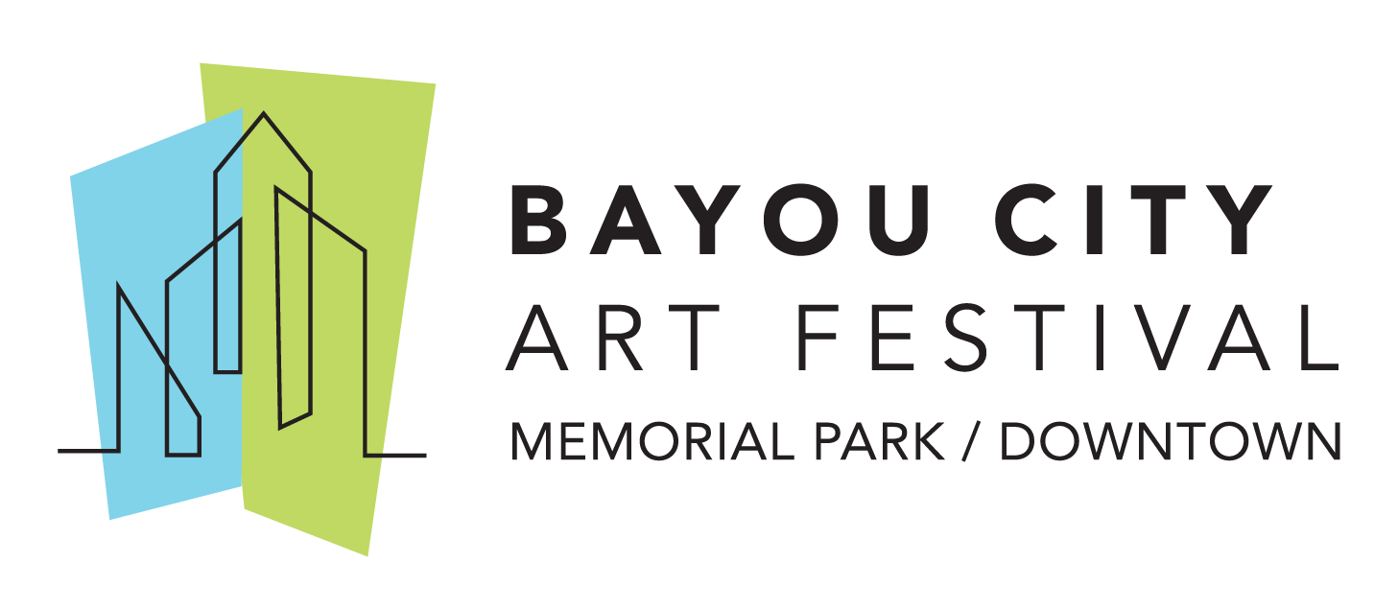
Media Contact
Kim Padgett
The Padgett Group
713-588-4130
kim@thepadgettgroup.com

Bayou City Art Festival Announces Fall 2020 Virtual Experiences

Launches “Save Our Art” Campaign in Partnership with the City of Houston

HOUSTON (August 4, 2020) – The Art Colony Association, Inc. (ACA), the producers of Bayou City Art Festival, has announced plans to reimagine and reinvent Houston’s signature art event – Bayou City Art Festival Downtown originally scheduled for Saturday-Sunday, October 10-11, 2020.
“The decision to convert our Bayou City Art Festival Downtown to a virtual experience was difficult, but the health and safety of our community and our festival family is our top priority,” said Kelly Batterson, Executive Director of the Art Colony Association.

For almost five decades, Bayou City Art Festival has helped thousands of Houstonians create fond memories. In order for Bayou City Art Festival to continue its mission for another 50 years, the organization is launching Save Our Art - One Passion. One Purpose. One Community – a fundraising campaign in partnership with the City of Houston to support the arts and our local nonprofit partners. Individuals and corporations can ensure the Bayou City Art Festival’s return to Memorial Park and Downtown Houston and it’s programming in the community by committing to donate by sending a text SaveOurArt to 243725, donating via our website and Facebook page, or by participating in the many upcoming fundraising events.

Bayou City Art Festival remains committed to highlighting artists, supporting youth art education and providing Houstonians with unique art experiences while raising funds for the festival’s local nonprofit partners. In place of an in-person festival in 2020, a Bayou City Art Virtual Experience will take place the week of October 5-11, 2020 and will feature an art auction, virtual performances, art projects for kids of all ages with Bayou City Art Festival nonprofit partners, creative activities with Bayou City Art Festival sponsors and more.

In collaboration with the City of Houston and strong feedback from festival patrons, artists and volunteers, the decision to reimagine the art festival and rally the community was made by Bayou City Art Festival staff and its Board Members. In its 49 years, weather has been the only factor that has impacted the festival until this year when COVID-19 impacted all of the arts organizations and live events worldwide. As a result, all 2020 Bayou City Art Festival tickets will be honored at Bayou City Art Festival events in 2021.

For the most recent updates, follow the official event hashtags #HouArtFest and #BCAF, like the Facebook page, or follow on Twitter and Instagram. Also, subscribe to our newsletter here.

About Bayou City Art Festival:
In its 49th year since the founding of the Westheimer Art Festival, now known as Bayou City Art Festival, the Art Colony Association, Inc. has raised more than $3.6 million for local nonprofit programs from proceeds of its festivals. Bayou City Art Festival Memorial Park in the spring and Bayou City Art Festival Downtown in the fall has provided a venue for more than 20,000 artists to showcase their work to thousands of art lovers from all over the world. The festivals are funded in part by grants from the City of Houston through the Houston Arts Alliance, corporate sponsorships, private contributions, in-kind support and volunteer assistance.

Volunteer and sponsorship opportunities are available. For more information, please visit www.artcolonyassociation.org.
###

