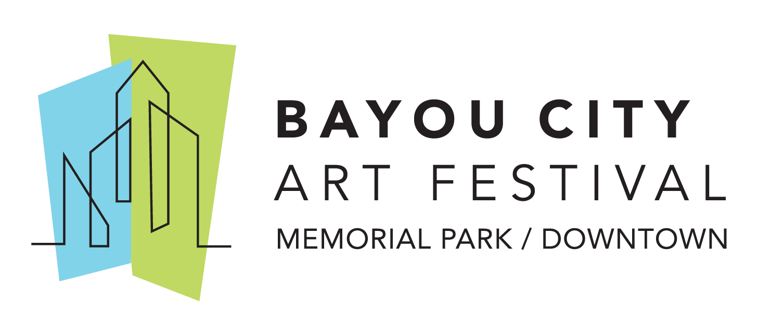
Media Contact
Kim Padgett
The Padgett Group
713-588-4130
kim@thepadgettgroup.com

Art Colony Association Announces Launch of Online
Bayou City Art Festival Marketplace

HOUSTON (June 17, 2020) – The Art Colony Association, Inc. (ACA), the producer of Bayou City Art Festival, has announced the launch of its online festival marketplace with 30 merchandise items available for purchase at www.artcolonyassociation.org/store.

The festival marketplace is located onsite at every Bayou City Art Festival and it is where patrons purchase branded festival merchandise and items that include the artwork from the festival’s featured artist. Guests can now shop online for festival T-shirts, a selection of posters, baseball caps, umbrellas, picnic blankets and more. New additions to the marketplace include koozies in a variety of colors with more to be added to the online store.

All proceeds from the online Bayou City Art Festival marketplace financially support the Bayou City Art Festival so that it can continue producing art festivals, provide a venue for artists to showcase their work, giving back to its local nonprofit partners, and supporting art education in Houston area schools.
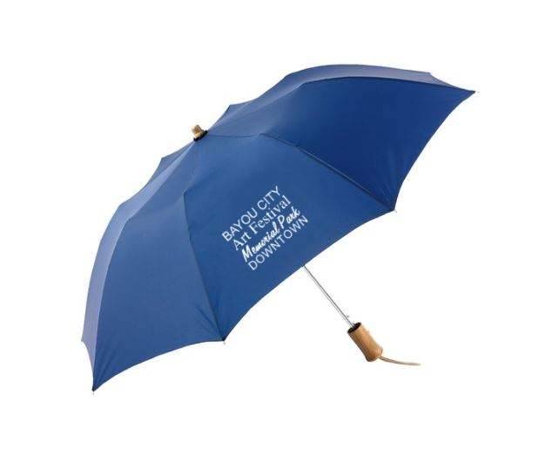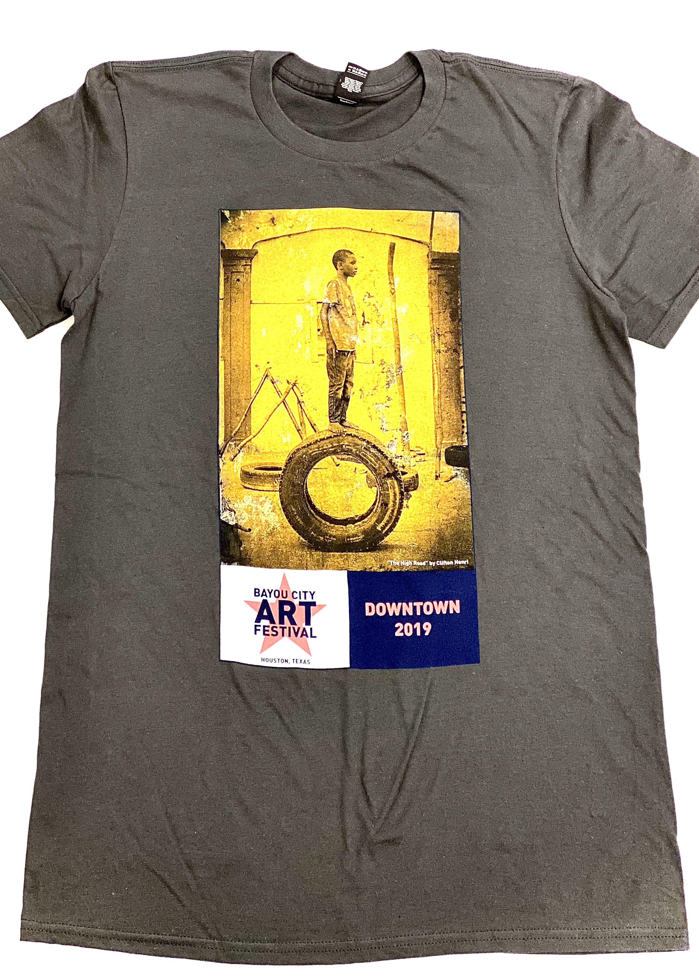
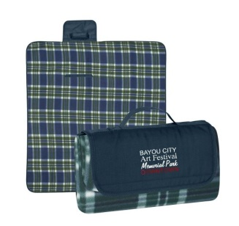
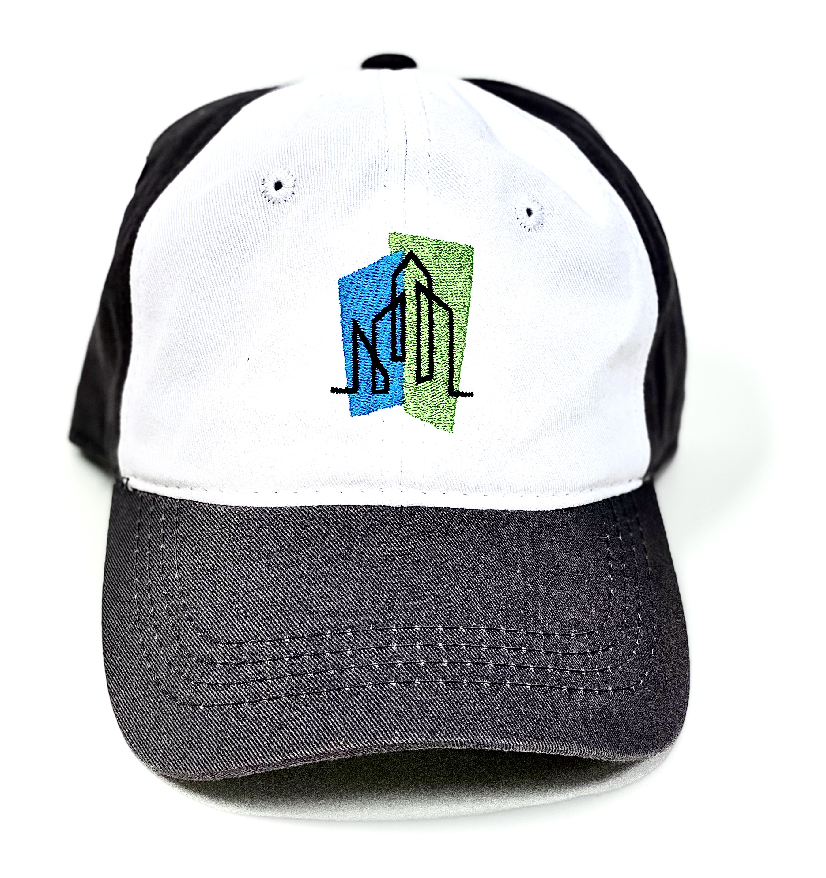

On October 10-11, 2020, Bayou City Art Festival will offer the city’s Downtown iconic buildings as a backdrop for guests to meet artists, view original works, and purchase one-of-a-kind art, prints, jewelry, sculptures, functional art and more. Bayou City Art Festival Downtown will feature artists, two music stages, a culinary arts stage with chef demonstrations, strolling live entertainment, food trucks, and a craft beer and wine garden. In the Children’s Creative Zone, the festival’s nonprofit partners will host art activities for all ages and include an interactive area for all attendees to enjoy. This year’s featured artist is McKenzie Fisk, a painter from Los Angeles.

For the most recent updates, follow the official event hashtags #HouArtFest and #BCAF, like the Facebook page, or follow on Twitter and Instagram. Also, subscribe to our newsletter here.

About Bayou City Art Festival:
In its 49th year since the founding of the Westheimer Art Festival, now known as Bayou City Art Festival, the Art Colony Association, Inc. has raised more than $3.6 million for local nonprofit programs from proceeds of its festivals. Bayou City Art Festival Memorial Park in the spring and Bayou City Art Festival Downtown in the fall has provided a venue for more than 20,000 artists to showcase their work to thousands of art lovers from all over the world. The festivals are funded in part by grants from the City of Houston through the Houston Arts Alliance, corporate sponsorships, private contributions, in-kind support and volunteer assistance.

Volunteer and sponsorship opportunities are available. For more information, please visit www.artcolonyassociation.org.
###

